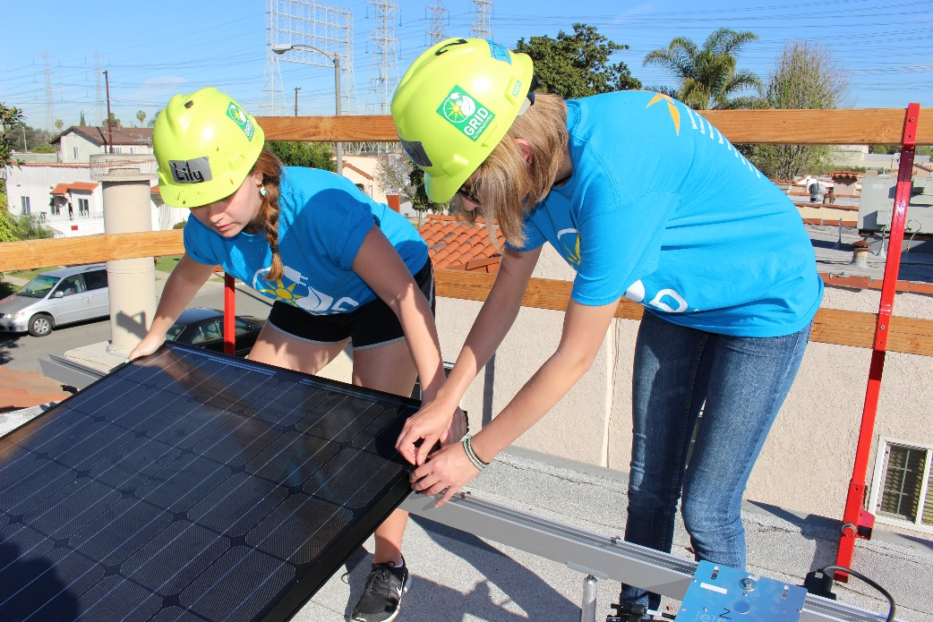

**GRID Alternatives** believes in a transition to clean, renewable energy that includes everyone. Its mission is to make renewable energy technology and training available to underserved communities. GRID is a non-profit organization and licensed solar contractor.

SOLARIZE

YOUR

COLLEGE

BREAK!

**"Solar Spring Break with GRID Alternatives on the Central Coast has been the best week of my life so far!”**  *-- Abhishek Rao, Arizona State University*

Soak us some sun and travel with the [University Name] Solar Spring Break team to make new friends and create a positive impact on our environment and low-income communities. **Get hands-on with renewable technology by installing a solar system from start to finish for a family in need**.

You’ll join other passionate students for a week of programmed activities, including two days of installing solar power! No experience required, we’ll teach you everything. Participants must be 18 or older.

Learn more at www.solarspringbreak.org

**Solar Spring Break Team Captain:**

Jane Doe, jdoe@university.edu

**Come to an informational meeting to learn more and join the team!**

Month, Day, Time

Location